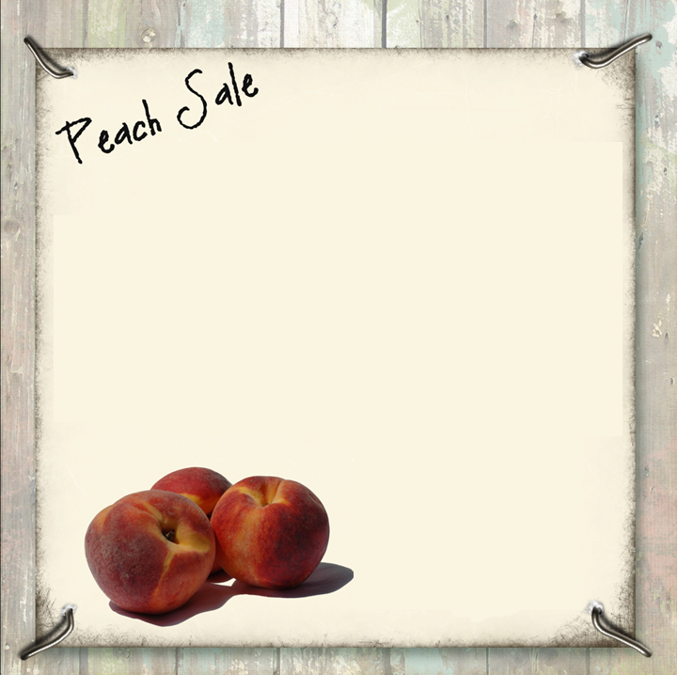

* Peaches are sold in 20 pound boxes (35-40 to a box).
* **Available to you for $35.00 a box**
* All orders and complete payment must be received at the Church on or before Monday, August 1st, 2016. Make checks payable to WPUMC. Mail or bring check to WPUMC, 1955 E. Arizona Avenue, Denver, CO 80210.

**WE WILL ONLY ACCEPT ONE CHECK PER ORDER**

**\*Peaches must be collected from Washington Park United**

**Methodist Church, 1955 E. Arizona Ave., Denver, CO**

**80210 on**

**Friday, August 12th, 2016, 12 p.m. (Noon) – 7 p.m. or**

**Saturday, August 13th, 2016, 9 a.m. – Noon.**

**NOTE: If you cannot pick them up, have a proxy. Any peaches not picked up on these dates will have a $5.00 storage fee and we cannot guarantee freshness after the pick-up dates***

*For further information call: Charlene Sullivan 720.209.3121 or the Church Office 303.777.3043

**ORDER YOUR FRESH PEACHES NOW!**

Complete the order form below and return it with your check for the total amount made payable to WPUMC by Monday, August 1st, 2016. Thank you for your order. **WE WILL ONLY ACCEPT ONE CHECK PER ORDER**

**NAME: ______________________________________________________________________________**

**ADDRESS:** _______________________________________________________________________________

**­**

**TELEPHONE: (Home)** _________________________________ **CELL:** ______________________________

**NUMBER OF BOXES REQUIRED: ___________ at $35.00 each. TOTAL ENCLOSED: $**_________________

----------------------------------------------------------------------------------------------------------------------------------

OFFICE USE ONLY: Paid date: __________ Amount Paid: ______________ Check # or Cash ____________

**Sweet, fresh, tree-ripened Palisade, Colorado Freestone peaches.**