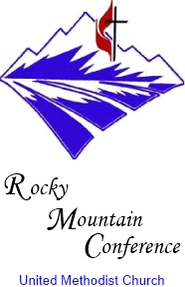

Denver Metro District

Paul J Kottke
Superintendent
pkottke@rmcumc.com

Cassy Chamberlin
Administrative Assistant
metro@rmcumc.com

May 7, 2017

Lana Banbury
Chair of Staff Parish Relations Committee
Washington Park United Methodist Church

Dear Lana,

It is my pleasure to announce that the Mountain Sky Area Bishop Karen Oliveto intends to appoint Jamielee Demske as the associate pastor for Washington Park United Methodist Church, effective July 1st. Jamielee will be coming from Trinity United Methodist where she is completing a two year Dr. James Barnes Internship.

Jamielee will be graduating from the Iliff School of Theology in November. She will be working both as a minister of youth and associate pastor, assisting Pastor Dillon.

Jamielee is in the process to be ordained Elder within the United Methodist Church. This Annual Conference in June, she will become a certified candidate.

Blessings in this time of transition, in the name of Jesus Christ,

Rev. Paul J. Kottke

Cc Jamielee Demske
Rev. Sandi Dillon
Bishop Oliveto

